OpenShift is a platform that allows you to run containerized applications and workloads, and it is powered by Kubernetes under the covers. There are many flavors available with OpenShift, and each helps streamline the day-to-day tasks for developers and operations engineers.

Link: <https://github.com/okd-project/okd>

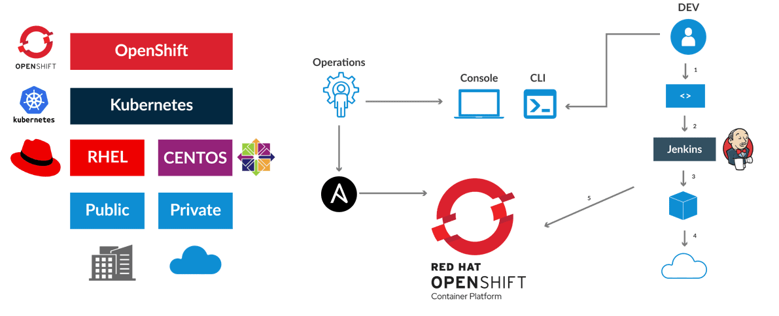

How OpenShift help Developer/OPS persons?

OpenShift uses jenkins and ansible to support automated container management.